**Installing Terraform on Windows OS**

**Step-1: Install Git Client**

* [Download Git Client](https://git-scm.com/downloads)
* This is required when we are working with Terraform Modules

**Step-2: Install Azure CLI**

* Install [Azure CLI](https://docs.microsoft.com/en-us/cli/azure/install-azure-cli-windows?tabs=azure-cli)
* Terraform - Authenticating using the Azure CLI .

# Azure CLI Login

az login

# List Subscriptions

az account list

# Set Specific Subscription (if we have multiple subscriptions)

az account set --subscription="SUBSCRIPTION_ID"

**Step-3: Install Terraform**

* [Download Terraform](https://www.terraform.io/downloads.html)
* [Install CLI](https://learn.hashicorp.com/tutorials/terraform/install-cli)
* Unzip the package
* Create new folder terraform-bins
* Copy the terraform.exe to a terraformbins folder

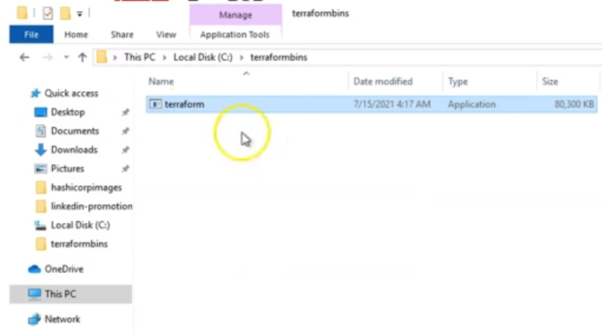

* Set PATH in windows

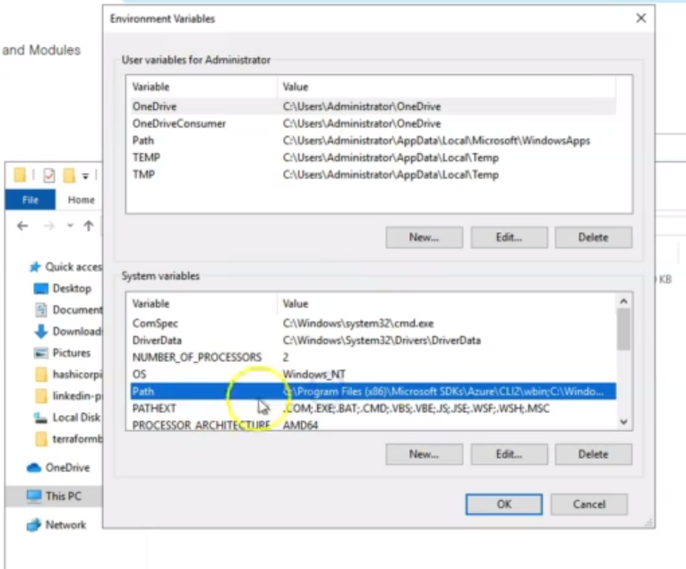

Click “Edit” and then click “New” and then paste the path where you copied terraform.exe and click OK.

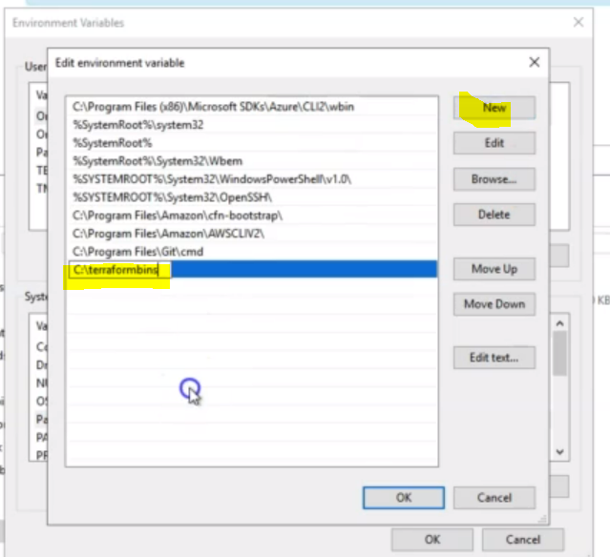

**Step-4: Configure Git Repo for this course - OPTINAL**

* Clone GIT Repo <https://github.com/samygitrepo/Terraform>
* Shorten Course folder name to smaller one. Put it in C:\ Drive root path

**Step-5: Install Visual Studio Code and Terraform Plugin**

* [Microsoft Visual Studio Code Editor](https://code.visualstudio.com/download)
* [Hashicorp Terraform Plugin for VS Code](https://marketplace.visualstudio.com/items?itemName=HashiCorp.terraform)
* Configure GIT Repo using VS Code Editor

**Step-6: WindowsOS: Long Path Issues for Terraform CLI**

* Our fix is to shorten our git repo name.